**PHYLUM PLATYHELMINTHES (Flatworms)**

The flat worms are the simplest animal group with bilateral symmetry and three distinct layers (triploblastic) yet without coelom. About 20,000 known species are mostly Parasitic in nature with only few free living species. The digestive cavity is branched, with only one opening. Flatworms have solid bodies, with no **circulatory** system for the transport of **oxygen** and food **molecules**. All cells are within diffusion distance of sources of oxygen and food due to their flattened nature which keeps the cells close to the external oxygen supply. Their body structure is well suited to fulfilling these requirements.

**Classification of the phylum**

1. **Turbellaria**: - which contains mostly free-living (non-parasitic) forms.
2. Trematoda:- encompassing parasitic flukes;
3. Cestoda: with tapeworms (also parasitic).

**Class Turbellaria e.g. Planarian**

These are free-living (non-parasitic) and most diverse group of flatworms that include 4500 known species divided into twelve orders. Majority of the organisms are found in an aquatic environment**.** Thefew terrestrial species are mostly **nocturnal** and live in shaded, humid locations such as leaf litter or rotting wood. They are **black** in colour and can measure up to 15mm in length. The body is **elongated** and extremely **flattened**, with relatively broad **anterior** head that possesses a pair of eyes on the dorsal surface, and a posterior end that is clearly tapered. Digestive tract is incomplete. The mouth leads to a pharynx, then to temporary spaces containing cells that take in food particles by phagocytosis. Movement is by secretion of slime from special skin glands, then gliding along by the beating of epidermal cilia. Turbellarians are mostly carnivorous..

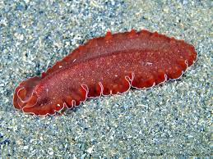 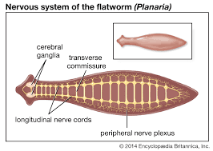

**Class Trematoda: Flukes**

About 9000 known species of trematodes are parasites of vertebrates. Their bodies are covered with a peculiar kind of epidermal arrangement referred to as **teguments** in which the main cell body is deep and separated from the cytoplasm that lies next to the exterior by a layer of muscle. The tegument lacks cilia in adults. Trematodes are characterized by the presence of **anterior** and ventral **suckers** that serve asattachment organs to their hosts. They are like turbellarians in having a relatively well developed alimentary canal. Their muscular, excretory, and reproductive systems are also relatively complete.

Most trematodes have complex life cycles, with larval stages (miracidium, sporocyst, cercaria metacercaria, radia) parasitizing one or more species that are different from host of adults. Most trematodes are endoparasites (parasites which live inside the host's body). They include several parasites that have an enormous impact on human populations, such as human liver flukes, and the blood flukes (*Schistosoma haematobium)* that cause Schistosomiasis.

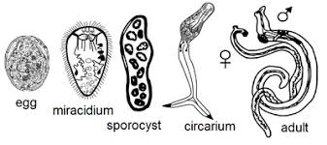

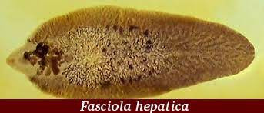 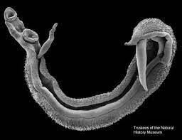

**Class Cestoda: Tape worms**

The Cestodes often referred to as tapeworms and they differ in a number of ways from other flatworms. Their bodies are long, flat and made up of many segments called **proglottids**. Each proglottid is a reproductive unit. Cestodes' teguments are covered with tiny projections (spicules or microvilli) which increase its surface area and thereby increasing its ability to absorb nutrients from their host. **Digestive** tracts and mouth are **absent** completely. Tapeworm’s anterior end is a specialized segment called a **scolex** (head) that is used for attachment. The scolex may be armed with **hooks** or a longitudinal groove called bothrium. Absorption of predigested food from the host is through the tapeworm’s skin. Tapeworms reside in the intestines of many vertebrates including humans, and may grow as long as five or six meters. They cause illnesses not only by encroaching on the food supply but also by producing wastes and by obstructing the intestinal tract. The most common human tapeworm is the beef tapeworm *(Taenia saginata)*. People are infected by eating undercooked flesh of cattle that have grazed on land contaminated by human feces containing tapeworm segments.

All of the 5000 or so known species of tapeworms require at least two hosts - with the host of the adult tapeworm a vertebrate and the Intermediate hosts often invertebrates.

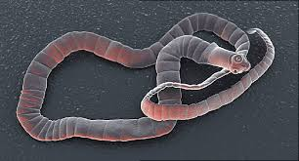

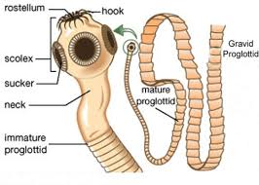 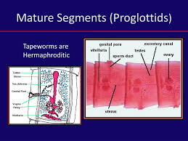

**PHYLUM NEMATODA: (ROUND WORMS)**

The word nematode which simply means thread-like (*Nema*: thread) belong to the phylum Nematoda. They are the most abundant and wide spread parasites group. Many species of nematodes are free-living in fresh or salt water, mud or soil while others are parasites of both animals and plants. They are characteristically elongated, cylindrical, bilaterally symmetrical, un-segmented with tapering ends.. The body is covered with a tough cuticle which may be smooth, striated, or spiny.

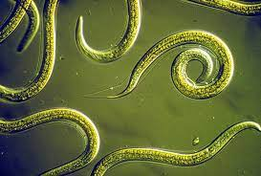 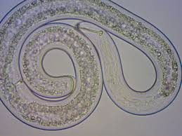

The adults vary great in size from less than 5mm (*Trichinella spiralis* and *Strongyloides stercolaris)* to 1meter (*Dracunculus medinensis*). The male is generally smaller than the female and its posterior end is **curved** or coiled ventrally. They have a body cavity with a high hydrostatic pressure, a straight **digestive** tract with an **anterior** terminal mouth and posterior sub-terminal anus. Excretory and nervous systems are rudimentary. Circulatory system is absent and the body wall consists of an outer layer of cuticle and an inner layer of longitudinal muscles.

The **sexes** are separate (dioecious). The male reproductive system consists of a long convoluted tube which can be differentiated into testis, vas deferens, seminal vesicle and ejaculatory duct which opens into the cloaca. The female reproductive system consists of an ovary, oviduct, seminal receptacle, uterus and vagina.

**Classification of nematodes**

Nematodes complete their life cycle in one host except in filarial nematodes and *Dracunculus medinensis*, which complete their life cycle in man and insect vectors as second hosts for the former and Cyclops as the second host for the latter.

**CLASSES OF NEMATODES**

Phylum Nematoda is divided into 2 classes: the **Adenophorea** and the **Secernentea**, both of which have parasitic members with the majority of the animal parasites belonging to the Secernentea.

**DIFFERENCES BETWEEN**

**CLASS ADEPHOREA AND CLASS SECERNENTEA**

|  |  |  |
| --- | --- | --- |
|  | **Adenophorea** | **Secernentea** |
| Eggs  Excretory system  Caudal papillae  Stage of larva infective to final host | With plug at either end  Without lateral canal  Absence or few  First larval stage | Without plug at either end  With lateral canal  Numerous  Third larval stage. |

REVIEW QUESTIONS

1. Succinctly discuss the adaptive feature of the flat worms to achieving transportation of oxygen and food materials.
2. Briefly explain why trematodes are said to have complex life cycles.
3. Differentiate between class Cestoda and class Trematoda.
4. Describe the body forms of the Cnidarians
5. Mention one or more of the adaptive features used by each of the following group of organisms to achieving transportation of materials a) Porifera b) Platyhelminthes
6. Describe at least three features that made the Hexactinella to present a distinct body plan from the generalized body plan of the sponges
7. Discuss in detail the morphology and generalized body plan of the Phylum Porifera.
8. Write short notes on the following:-
9. Acoelomate b) Triploblastic and c) Bilateral symmetrical.
10. a) Mention all the classes of phylum Platyhelminthes and

b) Discuss in detail any one (1) of the classes mentioned.

4. Discuss why you think the phylum Nematoda should not be classified alongside with Platyhelminthes.

5. Differentiate between the Medusoid and Polypoid body forms of the Cnidaria. Diagram is also important.